<<REDBULL TETRIS >>

Name L.Ishitha
Roll no 2420030041
Sec-10
Organized by: KLH University

Dates: 9 October, 2025

Brief Summary:
KLH University hosted an exciting Red Bull Tetris Game Competition that brought together students for a thrilling and fun-filled gaming experience. The event aimed to promote creativity, focus, and strategic thinking through interactive gameplay. Students participated enthusiastically, showcasing their quick reflexes and problem-solving abilities in the classic Tetris challenge powered by Red Bull.

Key Highlights:
- Organized in collaboration with Red Bull to promote gaming and cognitive skill development.
- High-energy atmosphere with multiple participants competing in live rounds of Tetris.
- Emphasis on concentration, strategy, and quick decision-making during gameplay.
- Winners were awarded exciting Red Bull merchandise and appreciation certificates.
- Encouraged a spirit of fun, teamwork, and healthy competition among students.
The event combined entertainment and skill development, creating an engaging experience for all participants.

My Participation:
I participated in the Red Bull Tetris Game event held at KLH University. It was an enjoyable and challenging experience that tested my quick thinking and hand-eye coordination. Competing with fellow students helped me improve my focus, adaptability, and strategic approach to problem-solving.
The event also gave me the opportunity to interact with peers in a friendly environment and experience the excitement of a live gaming competition.

<<Event Photographs>>
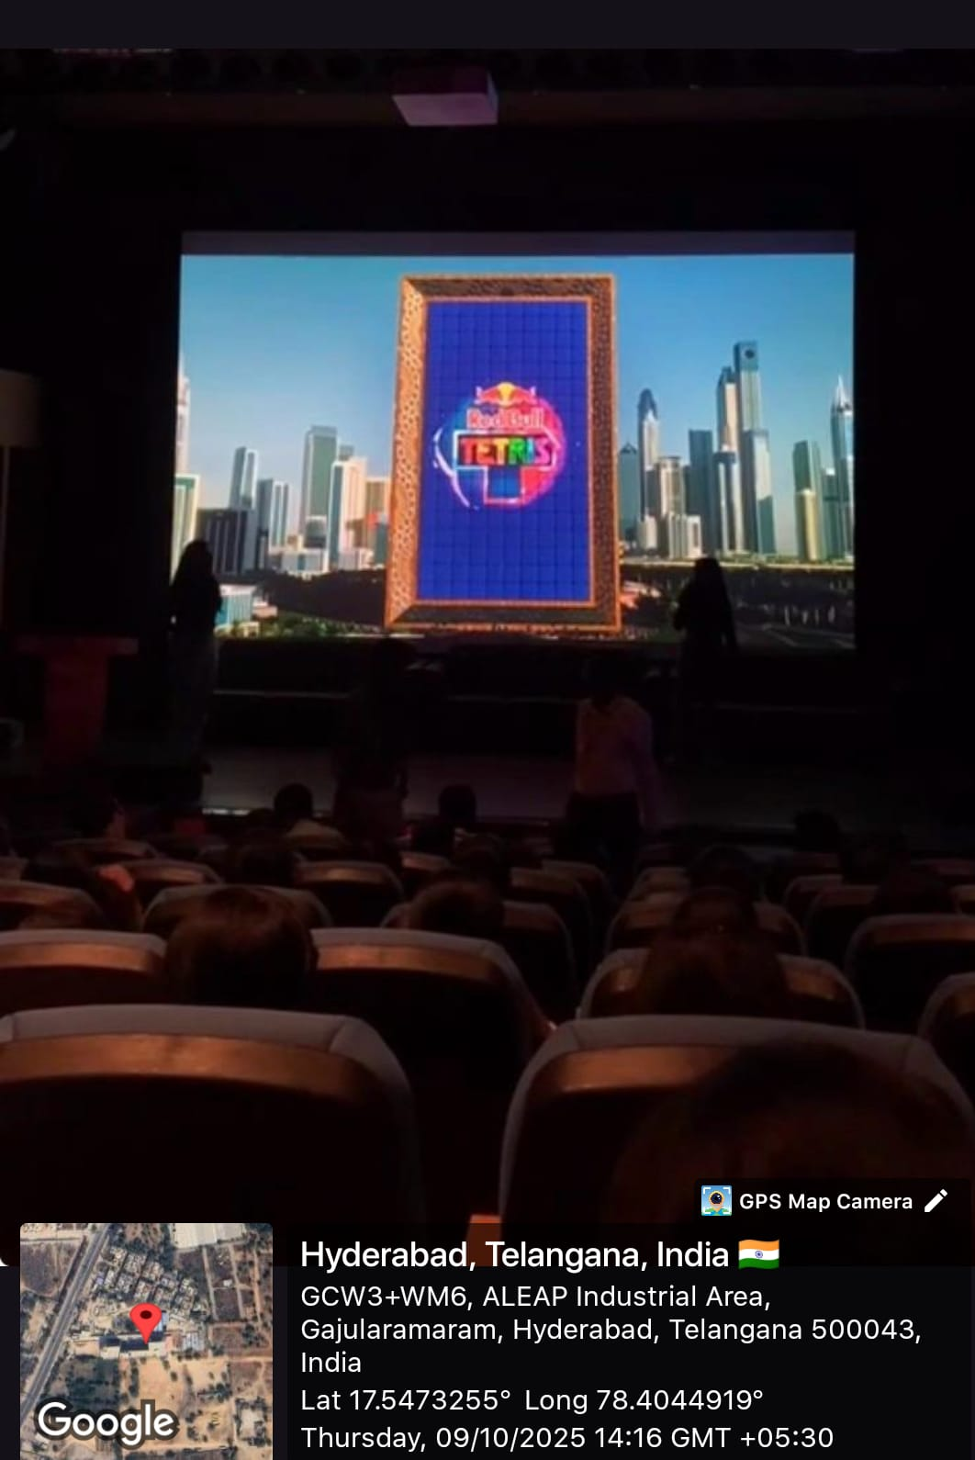

Conclusion:
In conclusion, the Red Bull Tetris Game event at KLH University was an exciting and refreshing experience that blended fun with learning. It encouraged students to think strategically, stay focused, and enjoy the spirit of competition. My participation in this event enhanced my concentration and teamwork skills while providing a much-needed break from academic routine.

Acknowledgment:
I would like to express my sincere gratitude to KLH University and Red Bull for organizing the Tetris Game Competition. Special thanks to the event coordinators and volunteers for their efforts in ensuring a smooth and enjoyable experience. The event was both entertaining and enriching, offering students a unique way to engage and challenge themselves.

